**Apple Gadgets**

Name: D.Madhu varsha

E-MAIL: madhuvarsha35@gmail.com

PhoneNo: 7396445916

RollNo: 20NN1A1210

College No: Vignan’s Nirula Institute of Technology and Science for Women.

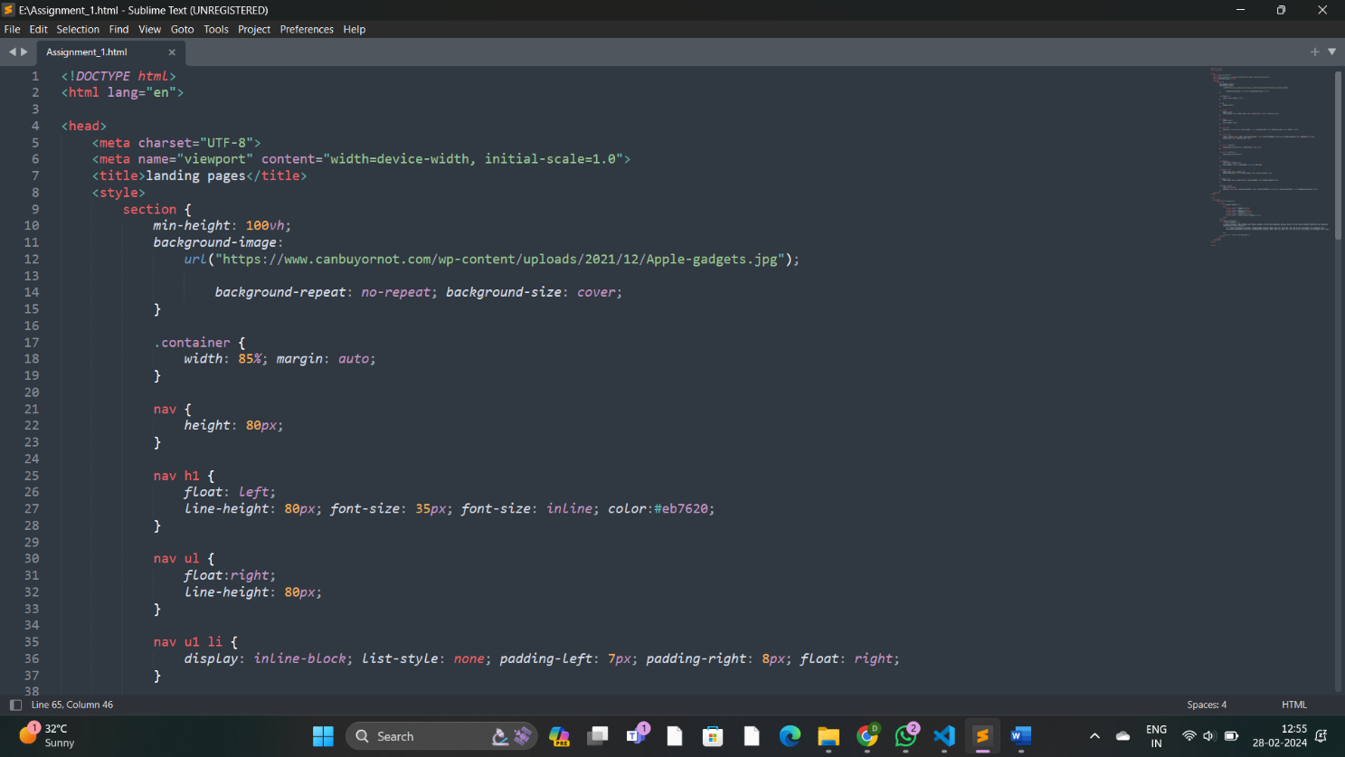**Source Code:**

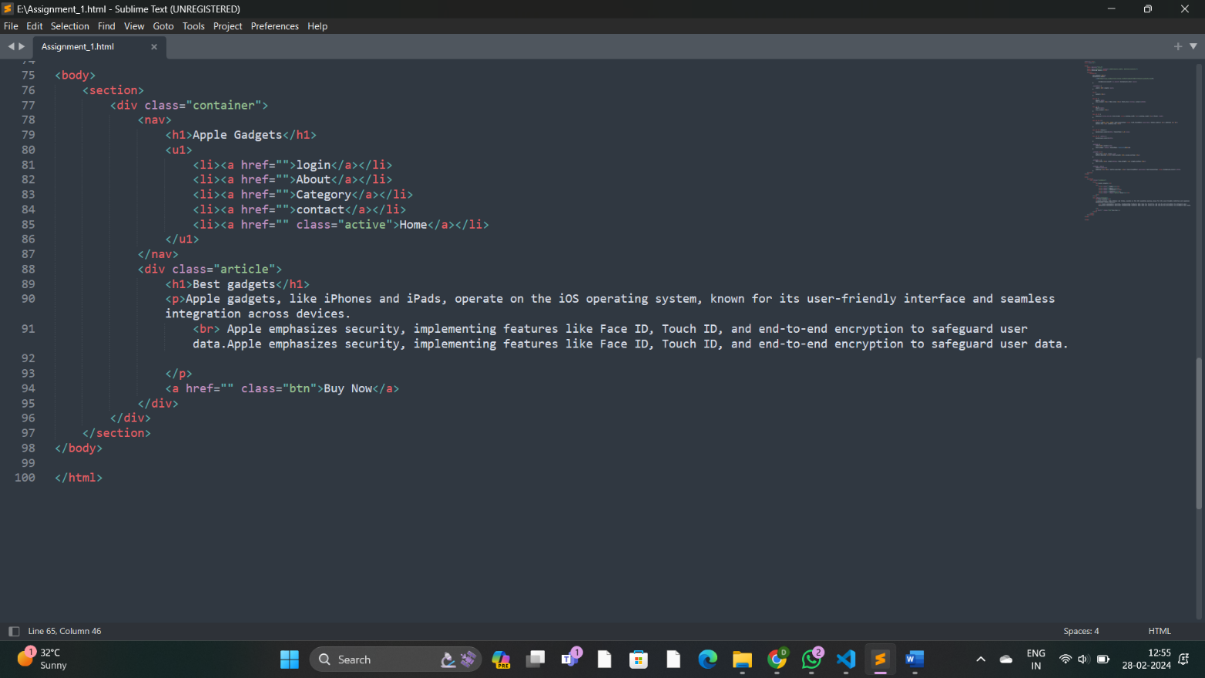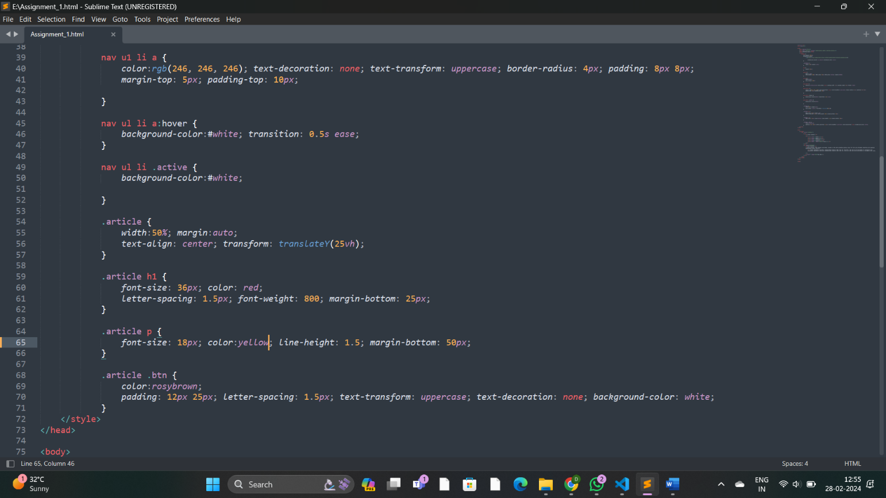

Output:

